**Assignment:**

**Connect with Database and Perform CRUD Operations**

This assignment is a step-by-step guide on how to connect a database using PHP and perform CRUD (Create, Read, Update, Delete) operations with SQL queries. This guide will cover the essential PHP code and structure you need.

**Step 1: Set Up Your Environment**

1. **Ensure XAMPP is Running**:
   * Start Apache and MySQL from the XAMPP control panel.
2. **Create a Database**:
   * Follow the previous assignment to create a database (e.g., mydatabase) and a table (e.g., users) with columns like id, username, and email.

**Step 2: Create a PHP File for Database Connection**

1. **Create a New Folder**:
   * Inside the htdocs directory of your XAMPP installation, create a new folder (e.g., crud_example).
2. **Create a File named db.php**:
   * This file will handle the database connection.

<?php

$servername = "localhost";

$username = "root"; // default XAMPP username

$password = ""; // default XAMPP password

$dbname = "mydatabase";

// Create connection

$conn = new mysqli($servername, $username, $password, $dbname);

// Check connection

if ($conn->connect_error) {

die("Connection failed: " . $conn->connect_error);

}

?>

**Step 3: Create CRUD Operations**

**3.1 Create ( Insert Data )**

1. **Create a file named create.php**:

<?php

include 'db.php';

if ($_SERVER["REQUEST_METHOD"] == "POST") {

$username = $_POST['username'];

$email = $_POST['email'];

$sql = "INSERT INTO users (username, email) VALUES ('$username', '$email')";

if ($conn->query($sql) === TRUE) {

echo "New record created successfully";

} else {

echo "Error: " . $sql . "<br>" . $conn->error;

}

}

$conn->close();

?>

<form method="POST" action="">

Username: <input type="text" name="username" required>

Email: <input type="email" name="email" required>

<input type="submit" value="Submit">

</form>

**3.2 Read (Display Data)**

1. **Create a file named read.php**:

<?php

include 'db.php';

$sql = "SELECT id, username, email FROM users";

$result = $conn->query($sql);

if ($result->num_rows > 0) {

echo "<table><tr><th>ID</th><th>Username</th><th>Email</th></tr>";

// Output data of each row

while ($row = $result->fetch_assoc()) {

echo "<tr><td>" . $row["id"] . "</td><td>" . $row["username"] . "</td><td>" . $row["email"] . "</td></tr>";

}

echo "</table>";

} else {

echo "0 results";

}

$conn->close();

?>

**3.3 Update (Modify Data)**

1. **Create a file named update.php**:

<?php

include 'db.php';

if ($_SERVER["REQUEST_METHOD"] == "POST") {

$id = $_POST['id'];

$username = $_POST['username'];

$email = $_POST['email'];

$sql = "UPDATE users SET username='$username', email='$email' WHERE id=$id";

if ($conn->query($sql) === TRUE) {

echo "Record updated successfully";

} else {

echo "Error updating record: " . $conn->error;

}

}

$id = $_GET['id'];

$result = $conn->query("SELECT * FROM users WHERE id=$id");

$row = $result->fetch_assoc();

?>

<form method="POST" action="">

<input type="hidden" name="id" value="<?php echo $row['id']; ?>">

Username: <input type="text" name="username" value="<?php echo $row['username']; ?>" required>

Email: <input type="email" name="email" value="<?php echo $row['email']; ?>" required>

<input type="submit" value="Update">

</form>

**3.4 Delete (Remove Data)**

1. **Create a file named delete.php**:

<?php

include 'db.php';

if (isset($_GET['id'])) {

$id = $_GET['id'];

$sql = "DELETE FROM users WHERE id=$id";

if ($conn->query($sql) === TRUE) {

echo "Record deleted successfully";

} else {

echo "Error deleting record: " . $conn->error;

}

}

$conn->close();

?>

**Step 4: Testing the Operations**

1. **To Create a User**:
   * Navigate to http://localhost/crud_example/create.php in your browser and fill in the form.

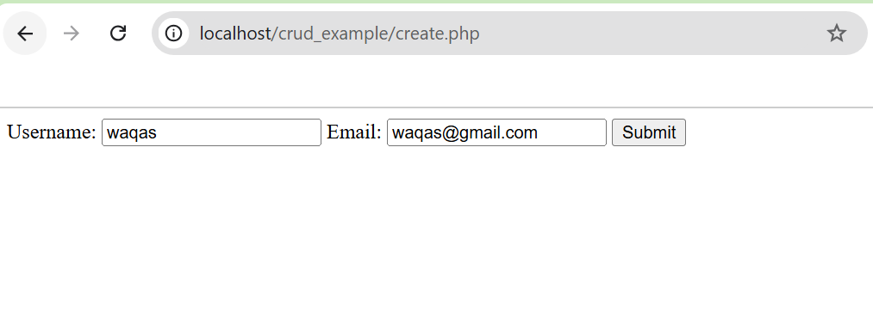

1. **To Read Users**:
   * Go to http://localhost/crud_example/read.php to see the list of users.

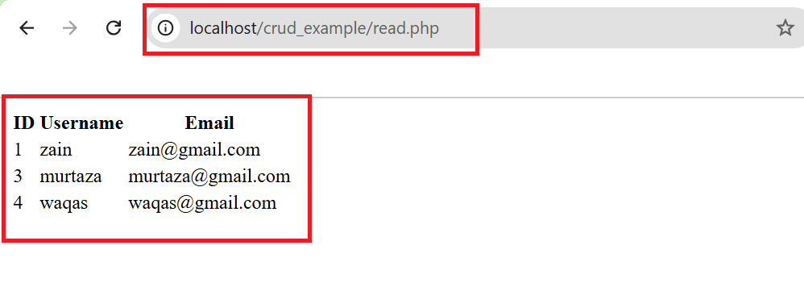

1. **To Update a User**:
   * You can create a link in read.php to update a user, e.g., <a href='update.php?id=<?php echo $row["id"]; ?>'>Edit</a>.

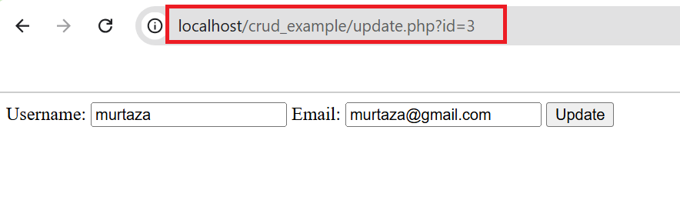

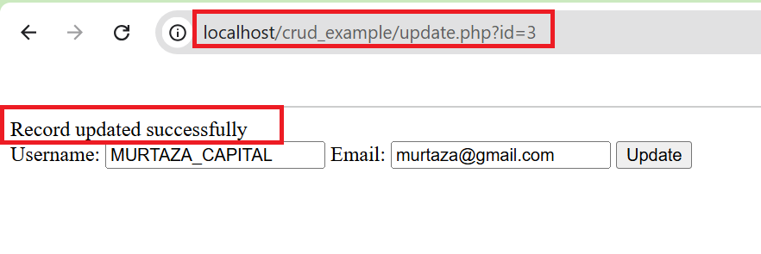

1. **To Delete a User**:
   * Similarly, add a delete link in read.php: <a href='delete.php?id=<?php echo $row["id"]; ?>'>Delete</a>.

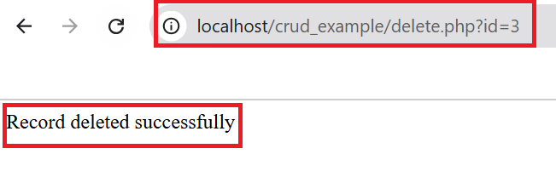

Record deleted successfully you can confirm from reading the remaining records:

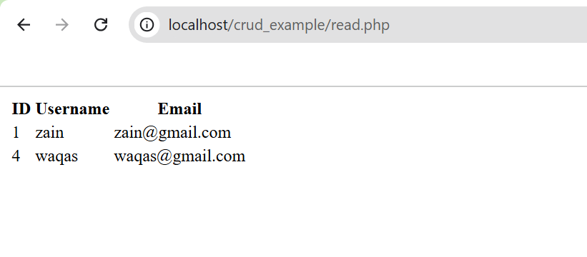

**Conclusion**

You have now created a simple PHP application that connects to a MySQL database using XAMPP and performs CRUD operations.